**eClub Traveler Newsletter: January 2020**

**SUBJECT LINES**

**[eCT newsletter subject line 1] Club Traveler: What to do, see and eat in Chicago this year**

**[eCT newsletter subject line 2] Club Traveler: From theme parks in Florida to peaceful temple tours in Japan, here’s how to plan your vacations**

**Welcome to *eClub Traveler*, a newsletter from the editors of Hilton Grand Vacations’ *Club Traveler* magazine. Each month, we’ll be sharing cities we're traveling to, the restaurants we’re visiting and the latest news about your Club membership, including tips on how to maximize your ClubPoints.**



Happy New Year from Hilton Grand Vacations! More than ever, we want to help you make the most of your Club membership. That’s why in 2020, we are continuing our free [Member Education Webinars](https://club.hiltongrandvacations.com/en/help/club-member-education-webinars), hosting Owner Social events at our properties, implementing an exclusive Owner Check-in area and offering [limited-time resort specials](https://club.hiltongrandvacations.com/en/club-membership/club-member-exclusives/limited-time-exclusives/resort-specials). To learn about these and other changes, [follow this link](https://club.hiltongrandvacations.com/en/help/new-year). A new year rings in a blank calendar full of days waiting to be filled with memorable travel. Let’s make 2020 a great one.

**[headline] A Welcome Note from Stan Soroka, Chief Customer Officer, Hilton Grand Vacations**

Happy New Year from Hilton Grand Vacations!

I hope you had a wonderful holiday season with family and friends. As we head into the new year, I want to take this opportunity to highlight new changes to your Club membership.

I am happy to announce we are continuing our **Club Member Education Webinars** in 2020. These free, professionally-facilitated sessions help you learn about your Club membership from the comfort of your home. Be on the lookout for our next event and visit the [webinar page](https://club.hiltongrandvacations.com/en/help/club-member-education-webinars) for playbacks of recent sessions.

We are also hosting weekly **Owner Socials** at our properties. These events provide you with an opportunity to network with fellow Members and resort staff, while hearing about the latest Club news. If you’re visiting us later in the year, stop by our dedicated **Owner Check-in**. We’ll be announcing the launch of this exclusive offering in the months to come. And, don’t forget to check your email to learn about our latest **Club Member Exclusives** featuring limited-time resort specials and free gift cards.

On the digital front, we’ll be working on upgrades to our ***Club Traveler*** magazine and ***eClub Traveler*** newsletter and continue to refine the **Club website** and **HGV mobile app**, which provide you with the best value when making a reservation. While there is no fee to book your Home Week reservation, if you prefer a vacation outside your Home Week, booking via the Club website or mobile app will deliver a 30 percent savings in fees compared to calling the contact center.

Speaking of the website and app, I hope you will take a moment to peruse photos of our **newly opened resorts** in [Barbados](https://club.hiltongrandvacations.com/en/resort/barbados/hilton-grand-vacations-at-the-crane?checkIn=2019-12-20&checkOut=2019-12-27), [Myrtle Beach](https://club.hiltongrandvacations.com/en/resort/south-carolina/ocean-enclave-by-hilton-grand-vacations-club) and [Chicago](https://club.hiltongrandvacations.com/en/resort/illinois-chicago/hilton-grand-vacations-chicago-downtown-magnificent-mile), or follow updates on our properties currently under construction in Los Cabos, New York City, Maui and Charleston. I am thrilled we are continuing to grow the outstanding list of properties for your enjoyment.

You may also notice some of our fees have increased in 2020. As our cost of doing business continues to rise, you will see changes reflected in certain transaction fees. Please review this year’s [Hilton Grand Vacations Club Fee Schedule](https://club.hiltongrandvacations.com/en/en/club-membership/hgv-club-fee-schedule) for further details.

At a time when many industries are relying on overseas operations or automated services, we remain committed to providing you with personalized care from our contact center in Orlando, Florida. Our **200+ skilled and trained Club Counselors** are ready to assist you six days a week with all your travel needs! [To be localized for Japanese version] If you prefer or need to call us, we offer an **interactive voice response system,** to expedite loan and maintenance fee payments, and a **Club call-back feature**, which results in a reduction of hold time during peak call times.

Finally, I am excited to announce **Yokoso HGV**, a new customer service program offered at our Hawaii properties. Derived from the Japanese word for *welcome*, the cultural program provides Team Members with a deeper cultural understanding when interacting with Japanese Owners and guests. [For Japanese version only]

A new year rings in a blank calendar full of days just waiting to be filled with memorable travel. Let’s make 2020 a great one.

Happy Travels!

Stan Soroka

Chief Customer Officer

**Chicago feature**

**[headline] Visit Chicago this year**

**[standfirst]** Whether you’re traveling for business or leisure, here’s our roundup of what to do and where to eat in Chicago in 2020, along with your optimal booking times for a stay with HGV.

**[text]**

With its world-class museums, iconic architecture and historic jazz clubs, Chicago ticks all the getaway boxes. Whether you’re exploring the city’s quirkiest neighborhoods or visiting its lakeside parks, we’ve rounded up the best ways to experience the Windy City like a local.

**[crosshead] Get Your Culture Fix**

Start your trip with a visit to the [**Art Institute of Chicago**](https://www.artic.edu), arguably the city’s grandest museum. The whole place is packed with jaw-dropping art, but be sure to see the Impressionist collection, which showcases iconic works by Claude Monet, Pierre-Auguste Renoir and Edgar Degas. For something a little more modern, head to the [**Museum of Contemporary Photography**](http://www.mocp.org) for an ever-rotating collection of visually-striking photography by local and international snappers.

**[crosshead] Catch a Jazz Show**

Skip the mainstream theaters and make for Chicago’s boutique jazz clubs instead. Once run by Al Capone, [**The Green Mill**](http://greenmilljazz.com)is something of a Chicago institution. Most months you can catch jazz pianist and vocalist Patricia Barber playing — but tickets sell out fast, so be sure to book ahead. Meanwhile, for local music talent slide into a seat at the new-ish [**Winter’s Jazz Club**](http://wintersjazzclub.com), a dimly-lit jazz and blues bolthole overlooking the Ogden Slip. Catch a show with a drink for $10 a ticket.

**[crosshead] Check out the Coolest Restaurants**

Follow the in-the-know locals to popular watering hole [**The Signature Room at the 95th**](https://www.signatureroom.com/)for cocktails and beautifully presented plates of upscale American cuisine, or head to [**Labriola**](https://www.labriolacafe.com) for what is arguably Chicago’s best deep dish pizza. Among them is [**ALTHEA by Matthew Kenney**](https://www.matthewkenneycuisine.com/althea),offering masterful interpretations of traditional dishes using all-vegan ingredients (think dumplings made from kimchi and coconut and a three-beet carpaccio).

**[crosshead] Be Indoors but Feel Outdoors**

Stay toasty with a visit to the frond-fringed, glass-topped [**Lincoln Park Conservatory**](http://lincolnparkconservancy.org), home to around 40,000 of the world’s most exotic plants. Built in the late 1800s and overlooking Lake Michigan, it’s the ideal spot for a fragrant break in between sights or simply somewhere to warm up when the famous Chicago wind picks up. There are regular flower shows, too, which run across the conservatory’s four houses (the Palm House, Fern Room, Orchid House, and Show House).

**Digital CTA:** Plan your Chicago vacation today. Visit [the resort page](https://club.hiltongrandvacations.com/en/resort/illinois-chicago/hilton-grand-vacations-chicago-downtown-magnificent-mile) to search for availability.



The iconic Cloud Gate sculpture, also known as *The Bean*, in Chicago’s Millennium Park

Credit: RomanSlavik.com/Shutterstock.com

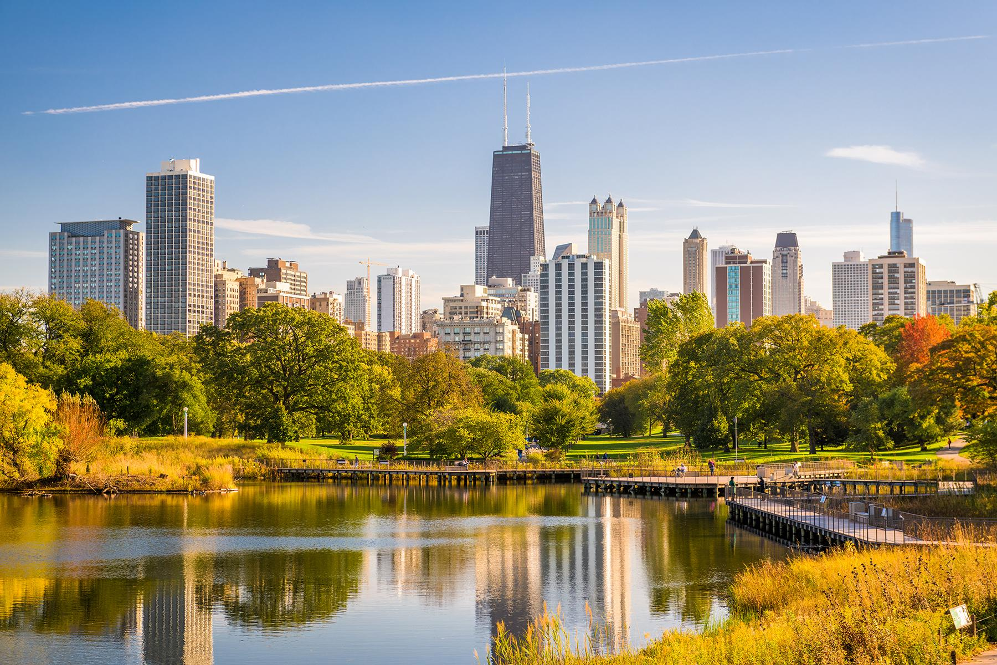

HERO IMAGE: A view of the Chicago skyline, as seen from Lincoln Park

Credit: Sean Pavone/Shutterstock.com

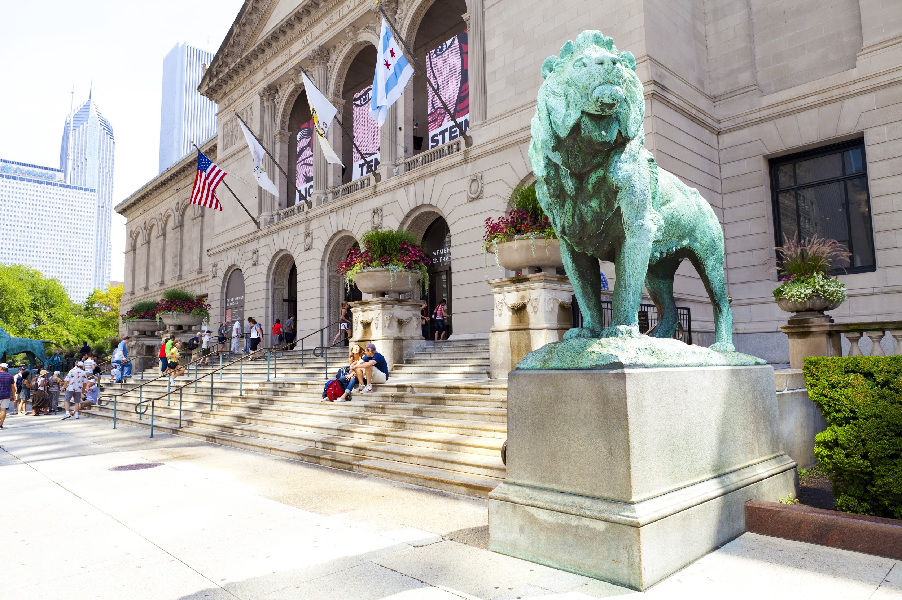

The Art Institute of Chicago, one of the largest art museums in the United States

Credit: MaxyM/Shutterstock.com

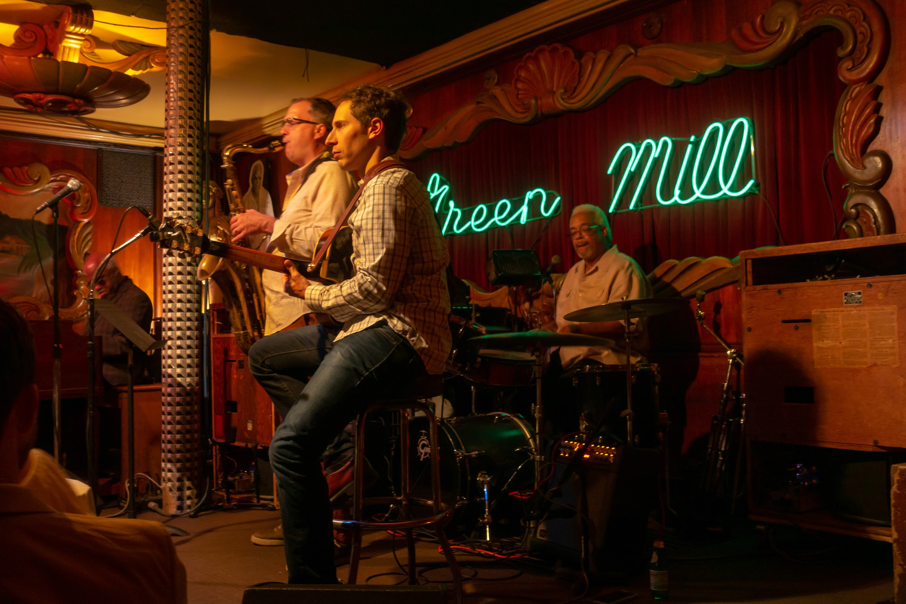

Musicians at Chicago’s iconic Green Mill Jazz Club

Credit: Anton Gvozdikov/Shutterstock.com

**[headline] Your 2020 Vacation Guide**

**[standfirst]** In time for National Plan for Vacation Day, we’ve created destination guides that’ll suit every traveler.

**[text]**

More than 50 percent of Americans don’t use all their yearly vacation days, according to the [U.S. Travel Association](https://www.ustravel.org/toolkit/national-plan-vacation-day?utm_source=MagnetMail&utm_medium=email&utm_content=12.11.19%20-%20NPVD%202020%20-%20Email%20#2&utm_campaign=ust). In time for National Plan for Vacation Day on January 28, we’ve created easy-to-read destination guides that’ll help you take advantage of your much-earned vacation time.

**Start Here: What kind of getaway are you looking for?**

**Vacation Type: For the sun seekers**

**Location: Orlando, Florida**

**Where to Stay:** [**Hilton Grand Vacations Club at SeaWorld**](https://club.hiltongrandvacations.com/en/resort/florida-central/hilton-grand-vacations-club-at-seaworld)

**Traveling with kids:** Home to no less than 12 theme parks including Walt Disney World, Universal Studios and SeaWorld, [Orlando](https://www.visitorlando.com/en/things-to-do/theme-parks) is a kids’ paradise. Our best tip? Save time and money by purchasing a package ticket in advance. Pint-sized film buffs will love the Universal Orlando Park-to-Park ticket, which includes entry to Universal Studios, Universal’s Islands of Adventure, and Universal’s Volcano Bay water park.

**Traveling as a couple:** Skip the school holidays and book your Orlando trip for May 2020 to coincide with the [Orlando International Fringe Theater Festival](https://orlandofringe.org/), a two-week arts and culture celebration — most of which takes place outdoors. Or, for skyline views, take a ride on the Wheel at Icon Park, which reaches 400 feet in the air.

**Traveling with the family:** Family members of all ages will love the [Kennedy Space Center](https://www.kennedyspacecenter.com/) at Cape Canaveral. An hour’s drive from Orlando, it’s a fascinating, fun look into Space-Age research and development. Don’t miss the interactive astronaut training experience, where you can navigate across Mars and try spacewalking.

**Vacation Type: For the culture mavens**

**Location: Chino, Nagano, Japan**

**Where to Stay:** [**Hotel Harvest Tateshina**](https://club.hiltongrandvacations.com/en/resort/japan/hotel-harvest-tateshina)

**Traveling as a couple or with the family:** Get your bearings with [Viator](https://www.viator.com/en-GB/tours/Nagano/Zenkoji-Temple-and-Snow-Monkey-Day-Tour-in-Nagano/d23523-9582P2)’s *Zenko-ji Temple, Snow Monkeys, Sake Tasting* tour, which takes in Nagano’s most famous sights and parks, and includes lunch and a sake tasting. The tour bus is air-conditioned and comfortable, and if any family members would rather sit out an activity, that’s an option, too. Tours tend to sell out, so we’d advise booking sooner rather than later.

**Traveling with kids:** Keep the little ones entertained with a ride on [Kitayatsugatake Rope Way](https://www.kitayatu.jp/ropeway/), a gondola that runs from Kita Yokodake in Chino, over the Japanese Alps, up to Mount Bandakeover. Kids will love the feeling of being suspended mid-air, while parents can admire the ever-changing alpine scenery. There’s a cafe and hiking trails at the top, too.

**Vacation Type: For the outdoor explorers**

**Location: Scotland**

**Where to Stay:** [**Hilton Grand Vacations Club at Craigendarroch Suites**](https://club.hiltongrandvacations.com/en/resort/scotland/hilton-grand-vacations-club-at-craigendarroch-suites)

**Traveling with kids:** Kids can spend some of their boundless energy with a family hike along one of the hundreds of trails that criss-cross [Cairngorms National Park](https://cairngorms.co.uk/discover-explore/things-to-do/walking-trails/community-paths-and-trails/). Many cut through mountains and forests, showcasing some of Scotland’s most beautiful scenery on the way. Bring a day pack with lunch and water, as not all walks include rest stops.

**Traveling as a couple:** Spend an afternoon relaxing at the luxurious [Craigendarroch Suites](https://club.hiltongrandvacations.com/en/resort/scotland/hilton-grand-vacations-club-at-craigendarroch-suites). Nestled in the Cairngorms National Park, the property features a spa, swimming pool and tennis court, designed to help guests relax and rejuvenate.

**Traveling with the family:** A short drive from Craigendarroch Suites lies [Balmoral Castle](https://www.balmoralcastle.com/), the Scottish holiday home of the British Royal family. There’s a range of easy, guided walks around the property, and during the winter they even run special Land Rover safaris. The grounds, gardens, exhibitions and cafe are open daily from April 1 to August 3.

**Digital CTA:** [Start planning your vacations now.](https://club.hiltongrandvacations.com/en/vacation-experiences)



Hero image: Many of HGV’s hotels are in family-friendly destinations

Credit: Shutterstock.com



National Plan for Vacation Day encourages Americans to plan their yearly vacations with family

Credit: Shutterstock.com

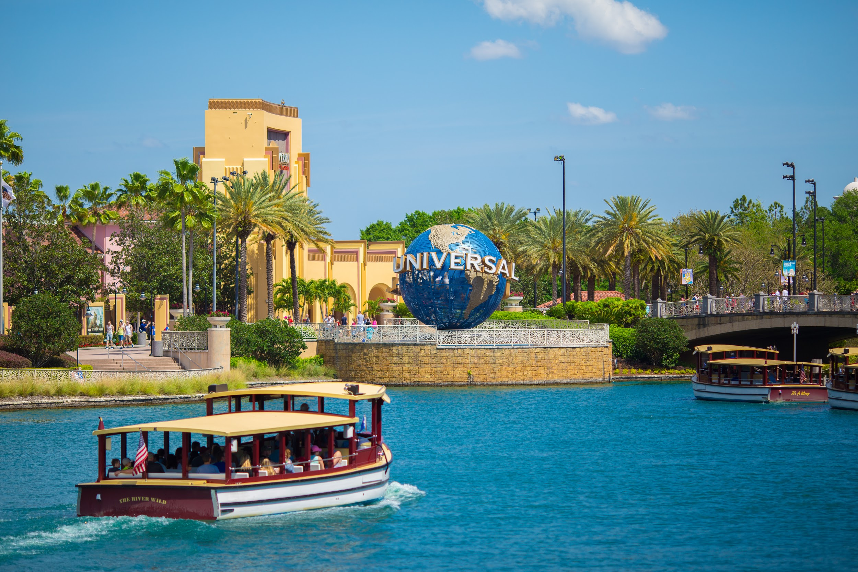

A boat trip across the waters at Universal Studios, Orlando

Credit: Mia2you/Shutterstock.com

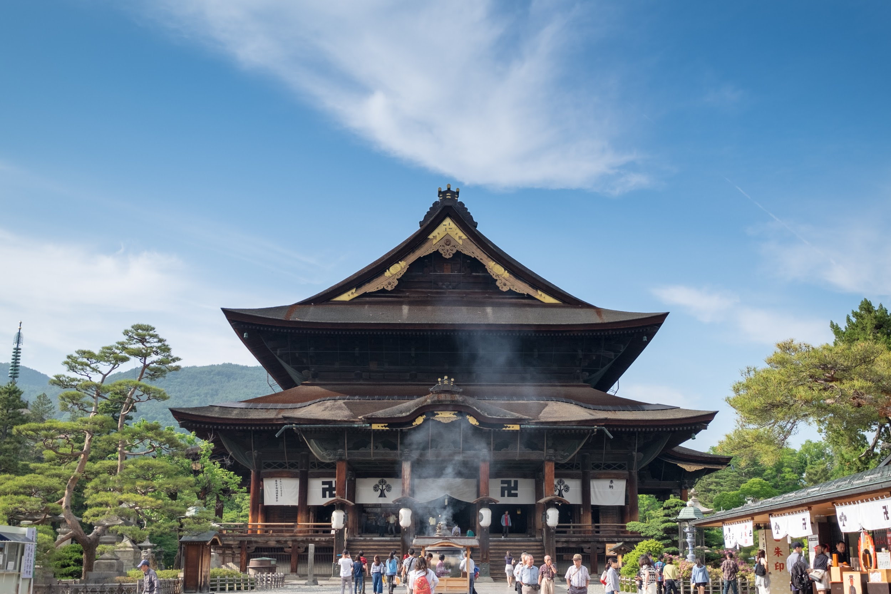

Zenko-ji is a popular Buddhist temple in Nagano, Japan

Credit: kittis/Shutterstock.com

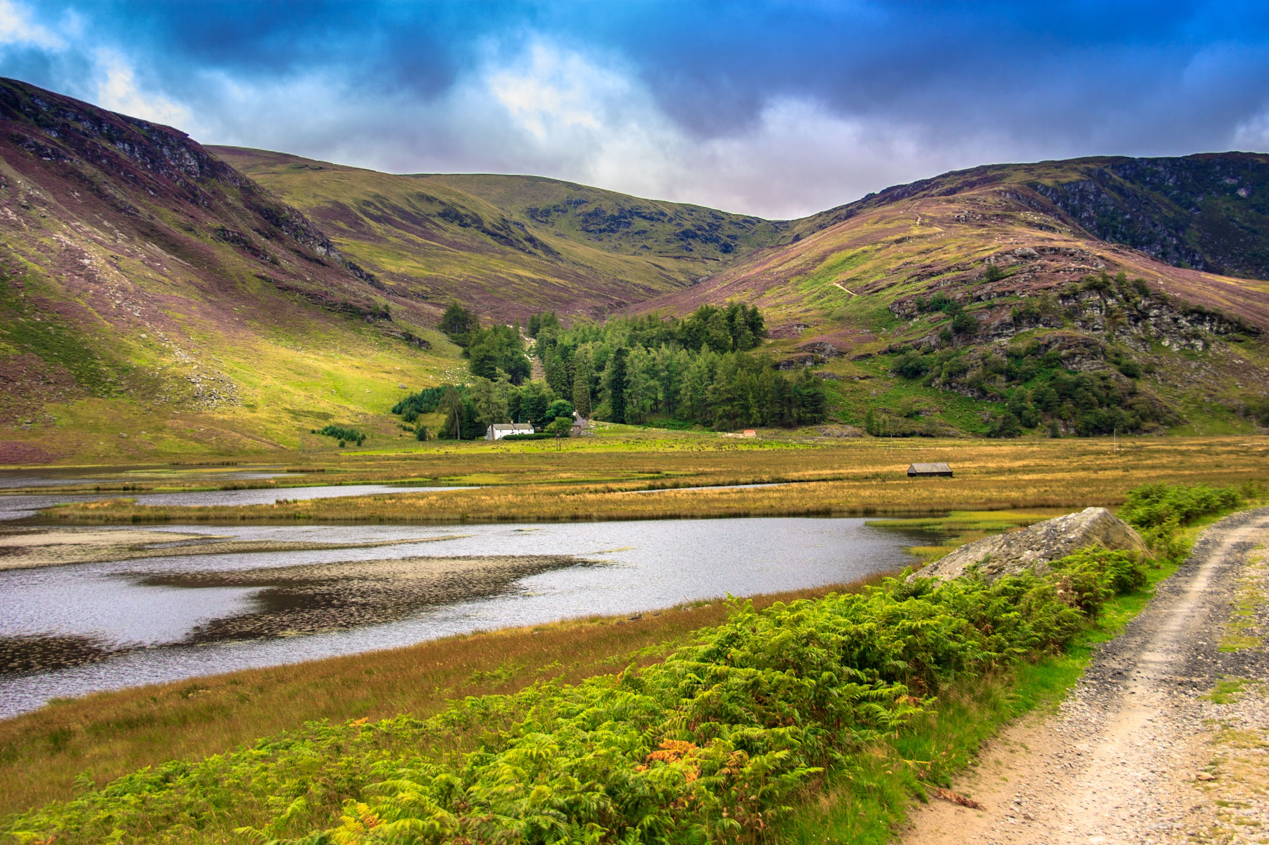

Scotland’s Cairngorms National Park has walking and cycling trails for the whole family, as well as places for climbing and canoeing

Credit: Shutterstock.com

**[headline] Myrtle Beach’s Best Bites**

**[standfirst]** From old-school Italian trattorias to Southern soul food diners, discover where to eat in Myrtle Beach

Thanks to a beachfront location and tropical climes, it’s no surprise Myrtle Beach attracts some of the region’s best chefs. Whether you’re after ocean-fresh seafood or niche pub cuisine, there’s a restaurant to suit everyone. Here, our pick of the best.

**Rendez-Views**

When it comes to beach views, there’s no better spot than Rendez-Views, the open-air bar and restaurant located at [Ocean Enclave by Hilton Grand Vacations Club](https://club.hiltongrandvacations.com/en/resort/south-carolina/ocean-enclave-by-hilton-grand-vacations-club). This is the tallest building on the waterfront, so go for the vista — but stay for the dishes, which span everything from Cuban panini stuffed with shredded pork, Swiss cheese and peppery mustard, to fresh berry salads with feta, walnuts and plenty of berries. It’s open for lunch and dinner daily, but come evening it turns into one of the beach’s most stylish drinking dens, with skilled mixologists conjuring up cocktails such as the ever popular Lo-Tide Rhum Bucket, made with lime vodka, coconut rum, sprite and lime juice. Think of it as a vacation in a glass.

**Sole Italian Restaurant**

For pastas like mamma used to make, book a table at family-run Italian joint [Sole Italian Restaurant](https://www.facebook.com/soleitalianrestaurant/), where owners Carlos and Patricia Ribera serve plates piled high with crunchy, bread-crumbed calamari, pillowy rolls of fried eggplant and classic caprese (tomato and mozzarella) salads — and that’s just the antipasto. We love the *linguini alla vongole* (linguine with clams plucked fresh from the sea) and the *vitello alla picatta* — juicy slices of veal topped with fresh lemon and capers. Save room for the homemade cannoli and tiramisu for dessert.

**Aspen Grille**

From chef and owner Curry Martin, [Aspen Grille](https://www.aspen-grille.com/) serves classic Southern cuisine with a twist. The seasonal menu champions hearty American fare: Think fried green tomatoes served with pecan-smoked bacon and parmesan, or fish with Carolina white rice, pea and corn succotash. There’s also a carefully curated wine list, plus live music courtesy of some of the area’s top musicians several times a week.

**Fire and Smoke**

Describing itself as a “chef-driven gastro pub,” [Fire and Smoke](https://www.facebook.com/fireandsmokegastropub/) serves tapas-style sharing plates of American comfort food with a twist. These guys pride themselves on sourcing all-local ingredients, such as Brasstown prime beef and the freshest seafood, and it shows. Expect the likes of freshly shucked oysters with bloody Mary granita, Nantucket Bay scallops on roasted tomato risotto and hickory-smoked Memphis-style ribs. Or for something a little more daring, try the buffalo meatloaf with blackberry chipotle glaze or the lobster cobbler with fennel pollen ice cream.

**Carolina Roadhouse**

With a menu packed with classic Carolina flavors as well as firm Southern favorites, it’s no surprise [Carolina Roadhouse](https://carolinaroadhouse.com/) has lines out the door. Kick things off with a bowl of Louisiana seafood gumbo, a wonderfully peppery soup stuffed to the brim with shrimp, oysters and andouille sausage. When it comes to mains, choose from generous seafood platters and perfectly-grilled steaks, or, for something smaller, go for the soft-shell crab po boy sandwich or the famous slow-roasted Roadhouse ribs.

**Digital CTA:** To visit Rendez-Views at Myrtle Beach, [book your stay at HGV Ocean Enclave now](https://club.hiltongrandvacations.com/en/resort/south-carolina/ocean-enclave-by-hilton-grand-vacations-club). If you are planning to book a vacation today for Ocean Enclave, you’ll find 3-night, 5-night and 7-night availability for January-March 2020.

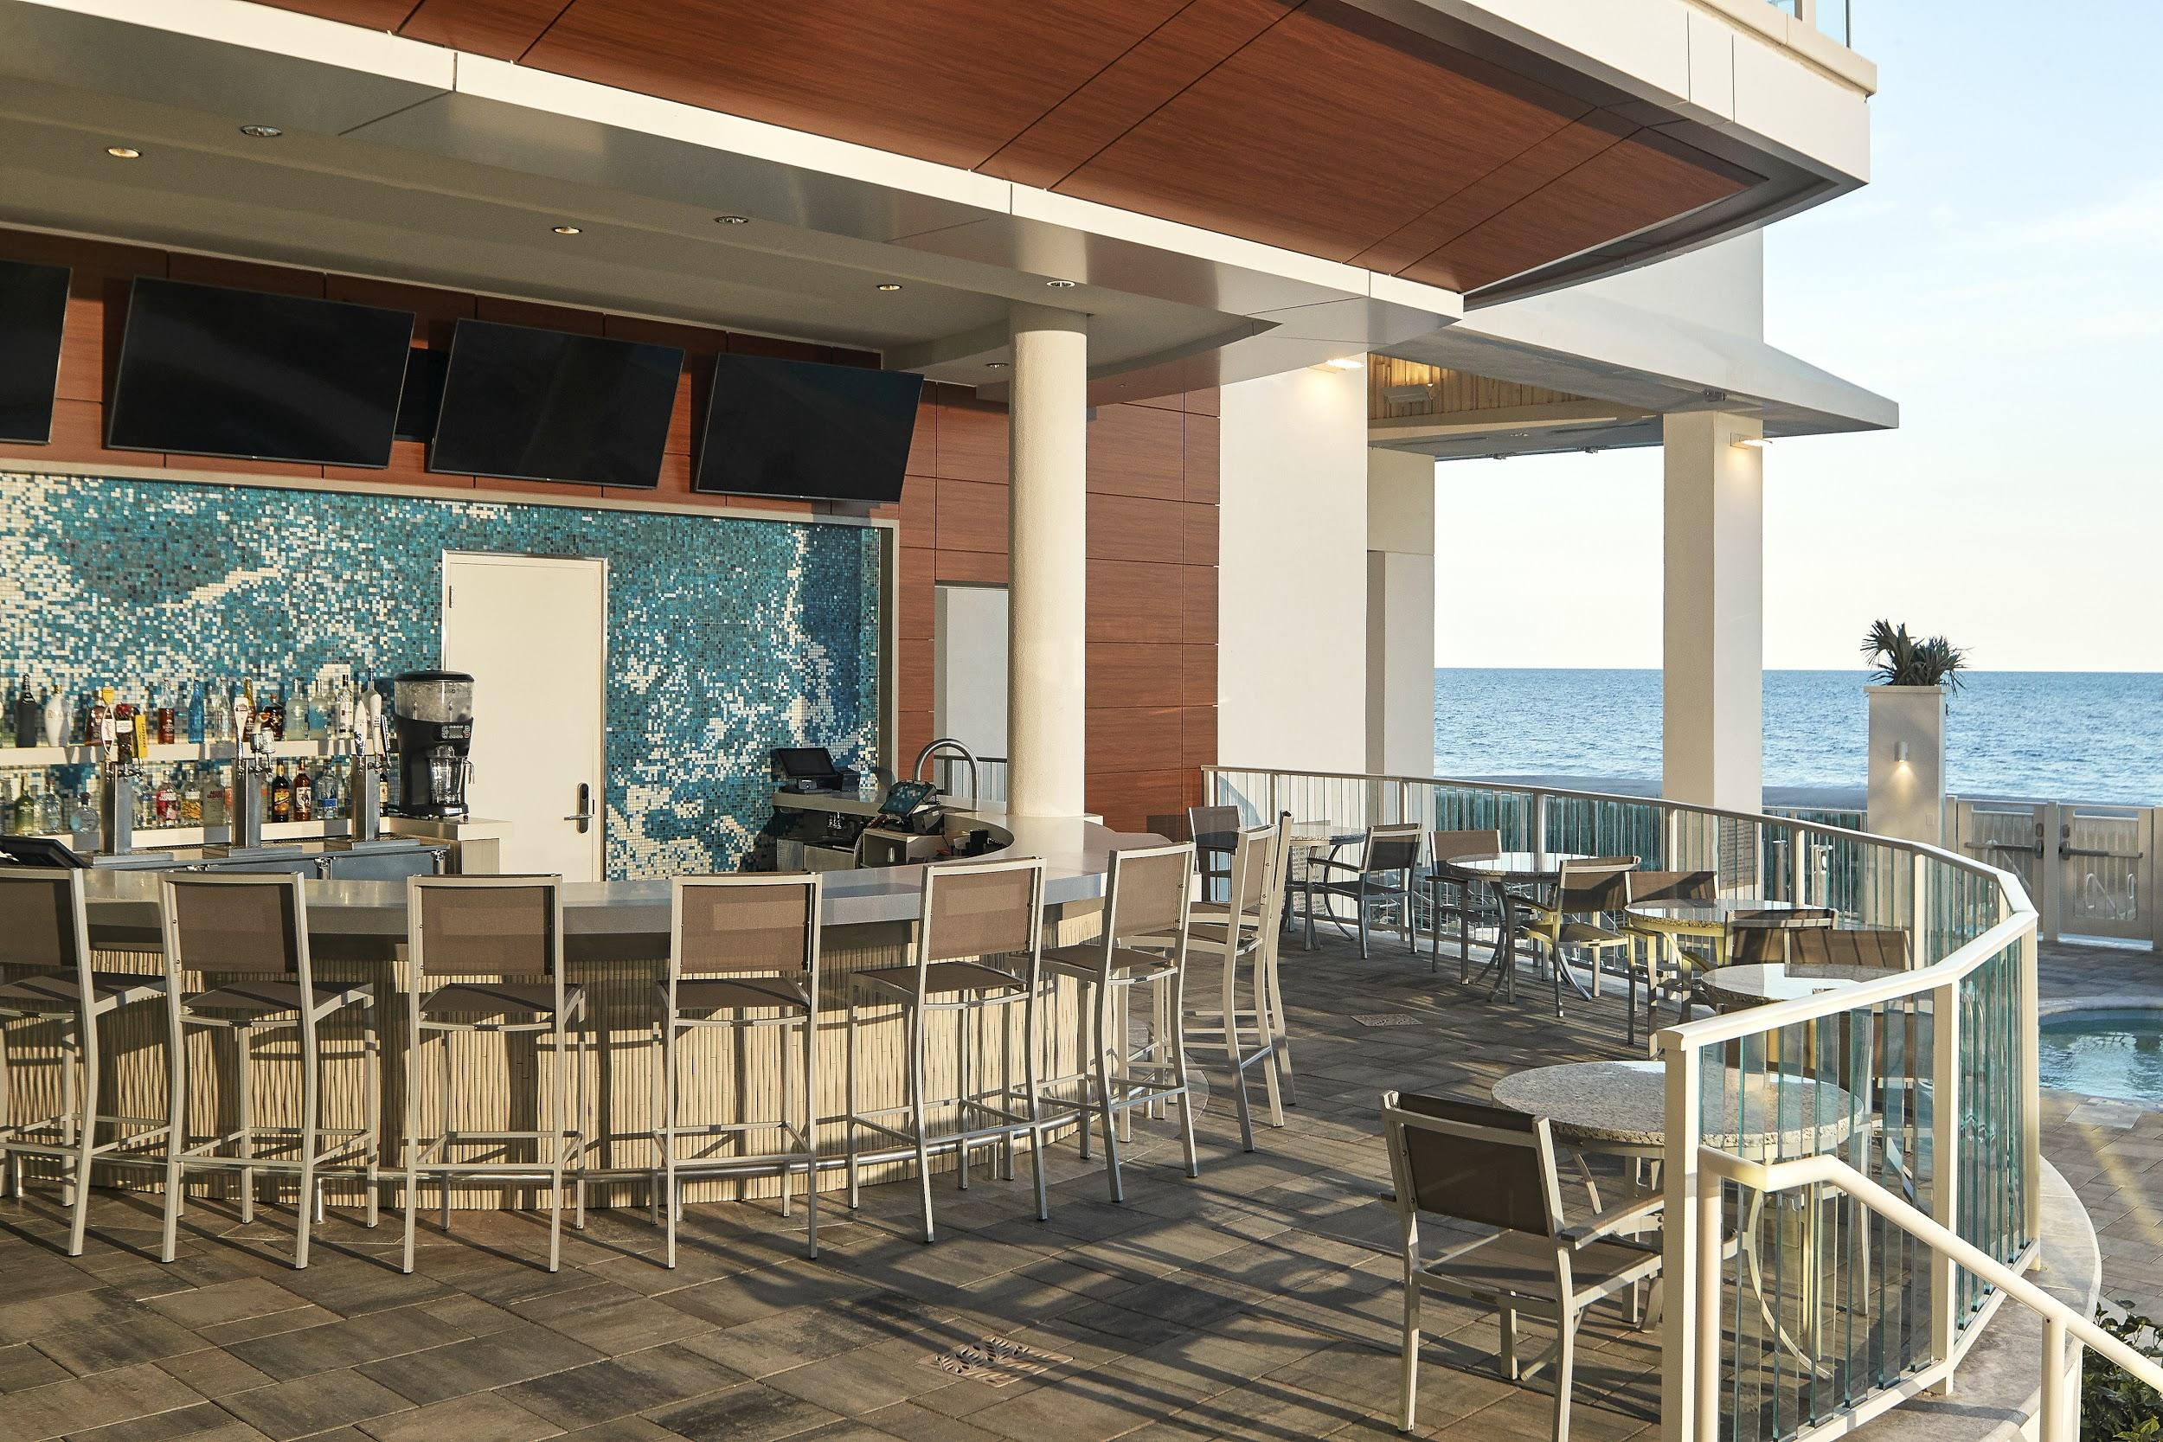

Hero image: The popular outdoor area at Rendez-Views at [Ocean Enclave](https://club.hiltongrandvacations.com/en/resort/south-carolina/ocean-enclave-by-hilton-grand-vacations-club) on Myrtle Beach

Supplied image

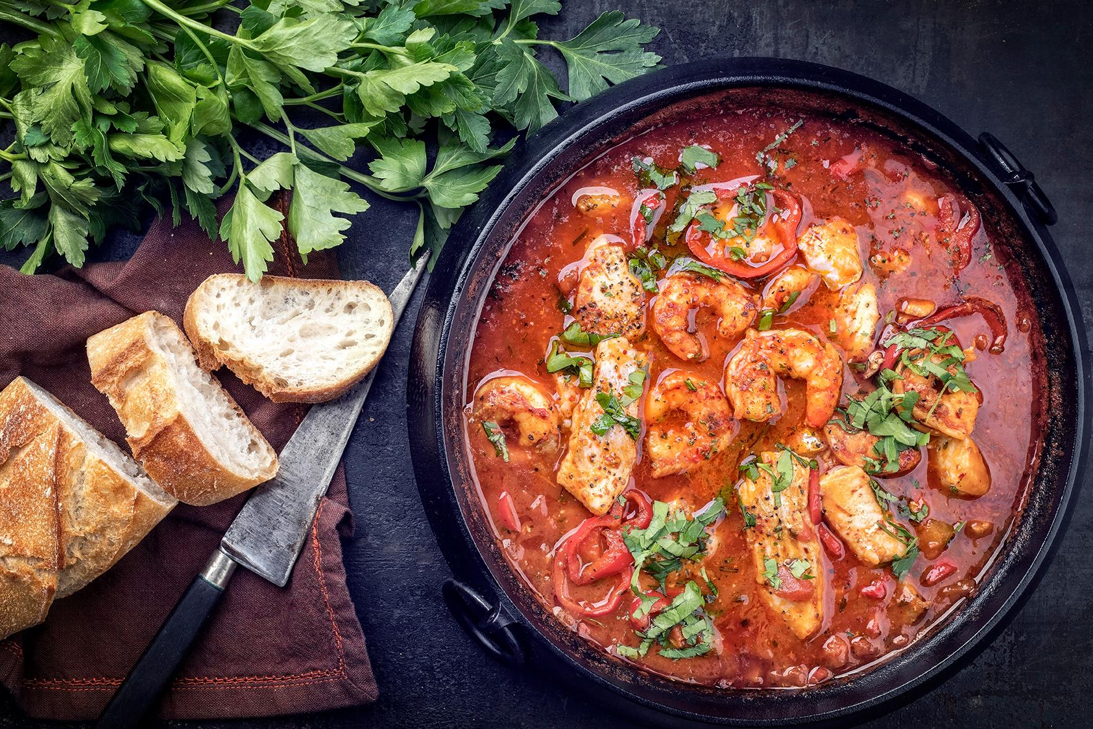

Visitors to Myrtle Beach can dine on classic Southern dishes such as seafood gumbo

Credit: hlphoto/Shutterstock.com

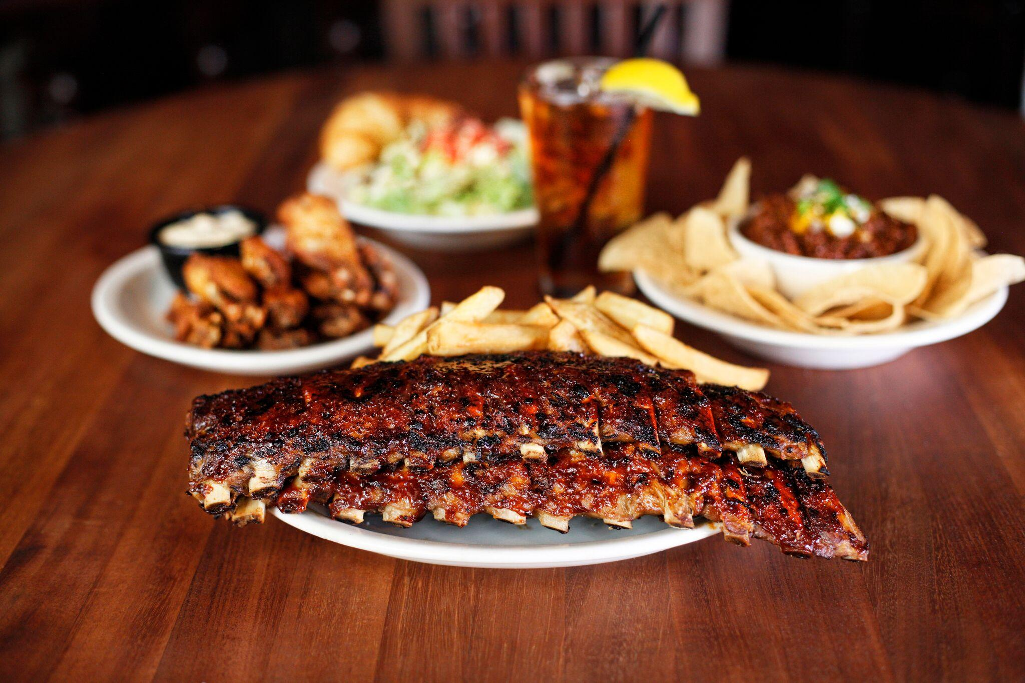

A plate of ribs served at Carolina Roadhouse

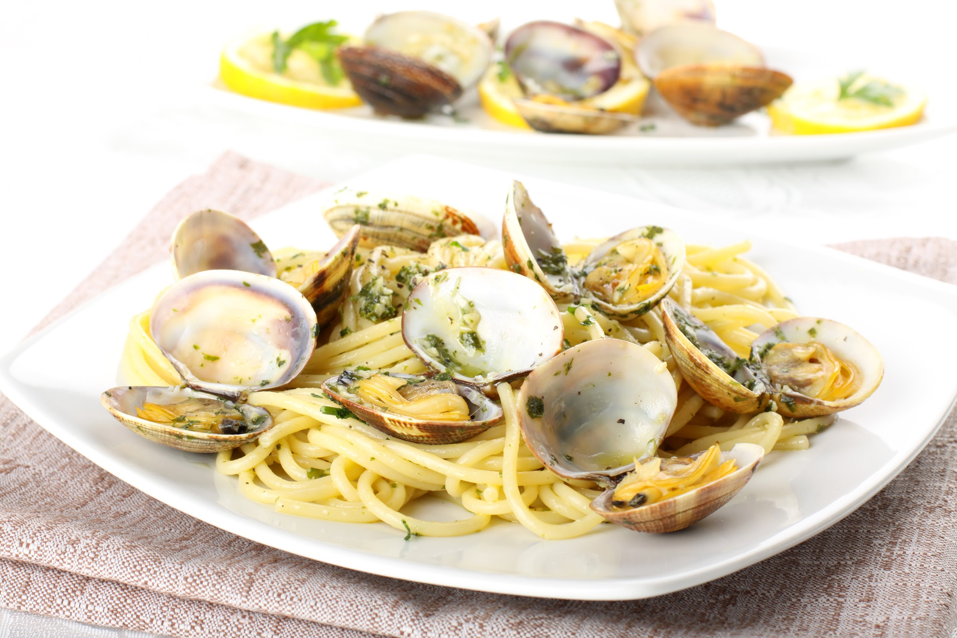

Linguine with clams is a popular dish at Sole Italian Restaurant

Credit: Shutterstock.com

[headline] **A Clean Record**

[standfirst] Discover Hilton Grand Vacations’ latest eco-friendly soap-recycling initiative

With an ever-increasing focus on ways to recycle more and reduce our impact on the natural environment, Hilton Grand Vacations is excited to announce its collaboration with Clean the World: A project that collects soap and bottle amenities previously discarded by the hospitality industry and, instead, sanitizes and recycles them.

Donated products will help 127 of the world’s most impoverished countries and help to prevent millions of hygiene-related illnesses and deaths each year. Hilton Grand Vacations is proud to partner with Clean the World as part of [Hilton’s Travel With Purpose program](https://www.hgv.com/en/news/press-releases/hilton-marks-global-handwashing-day-by-expanding-soap-recycling-effort-around-the-world), which is committed to eliminating all soap waste by 2030.

“A spirit of service has always been at the heart of Hilton Grand Vacations through our Corporate Social Responsibility platform – HGV Serves,” said Stan Soroka, Hilton Grand Vacations' chief customer officer. “We are thrilled to stand shoulder-to-shoulder with our fellow Hilton brands to amplify what has already been done and catapult this program further.”

To recycle the soap, HGV’s housekeepers collect used soap from guest rooms and place it in specially-created Clean the World soap collection bins. From there, the bins are transported to a facility that sanitizes and grinds the soap down, before pouring and molding it into new soap bars. New soap bars are then delivered to those in need – meaning you’re giving something back to the community while on vacation.

“In a world where too many children die of hygiene-related illnesses, Hilton and its soap recycling partners are turning guest room waste into life-saving treasure,” said Katie Fallon, Hilton’s Global Head of Corporate Affairs. “We are now expanding our industry-leading, global soap recycling program to all of our brands as part of our commitment to send zero soap to landfill.”

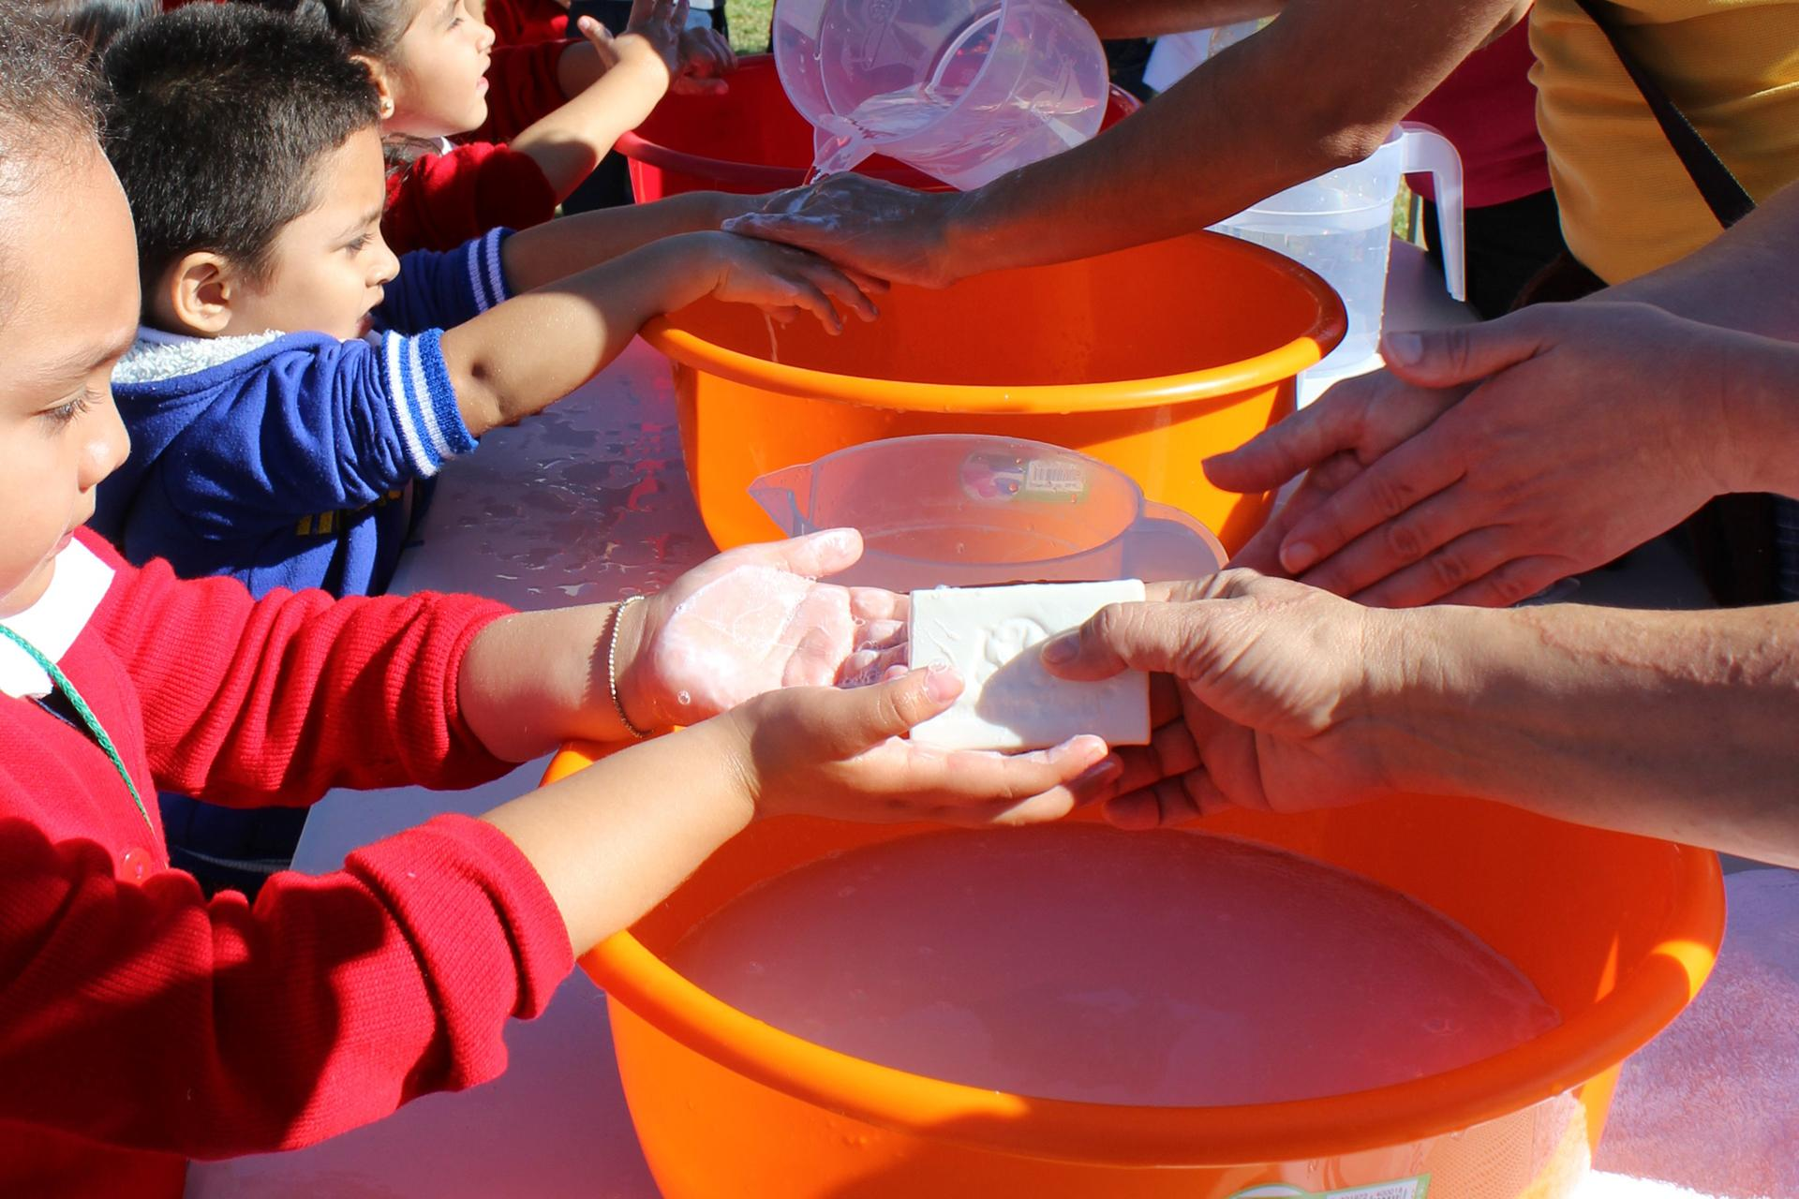

HGV is proud to partner with Clean the World as part of [Hilton’s Travel With Purpose program](https://www.hgv.com/en/news/press-releases/hilton-marks-global-handwashing-day-by-expanding-soap-recycling-effort-around-the-world), which is committed to eliminating all soap waste by 2030



Hero image: Clean the World collects discarded soap and bottle amenities and sanitizes and recycles them for future use



Soap bars are delivered to those in need, meaning HGV Club Members are giving something back to the community while on vacation

Credit: Supplied image

[headline] **Grand Adventures Await**

[standfirst] Have the vacation of a lifetime with our ClubPartner Perk Grand Adventure offerings

At Hilton Grand Vacations, our focus is not only on ensuring our Club Members experience the best when they travel with us, but also on rewarding their loyalty with access to some of the most covetable travel experiences available. In 2020 and 2021, those opportunities will be better than ever: Join a ClubPartner Perk Grand Adventure and not only will you travel alongside fellow Club Members, you’ll do so while staying in elegant staterooms at exceptional Members-only prices.

Why not join a [10-day cruise](https://club.hiltongrandvacations.com/en/club-membership/club-member-exclusives/clubpartner-perks/clubpartner-perk-grand-adventure/celebrity-edge-greek-isles-and-italian-coast) exploring the magnificent Greek Islands and the picturesque Italian coast, taking in the historic marvels of Rome and Athens, as well as the wineries of Santorini and the rustic beauty of Crete?

If you prefer a river cruise, plan now to join our [10-night Blue Danube Guided Journey](https://club.hiltongrandvacations.com/en/club-membership/club-member-exclusives/clubpartner-perks/clubpartner-perk-grand-adventure/the-blue-danube-tauck-guided-journey-river-cruise) in August 2021 with Club Partner Tauck. The itinerary includes two nights in Prague before spending seven nights exploring palaces, castles and inclusive Tauck private tours along the Danube River. End your trip in Budapest, with an extra day to explore both Buda and Pest.

And if you would like to keep your feet on dry land, there are two 2020 exclusive opportunities to [explore Scotland’s Highland charms](https://club.hiltongrandvacations.com/en/club-membership/club-member-exclusives/clubpartner-perks/clubpartner-perk-grand-adventure/journey-through-scotland-with-tauck) and charismatic cities, or visit [New Orleans’ exceptional cultural and culinary riches](https://club.hiltongrandvacations.com/en/club-membership/club-member-exclusives/clubpartner-perks/clubpartner-perk-grand-adventure). Whichever vacation you select, a Grand Adventure awaits you.

**Digital CTA:** Book your [Grand Adventure](https://club.hiltongrandvacations.com/en/club-membership/club-member-exclusives/clubpartner-perks/clubpartner-perk-grand-adventure) now.

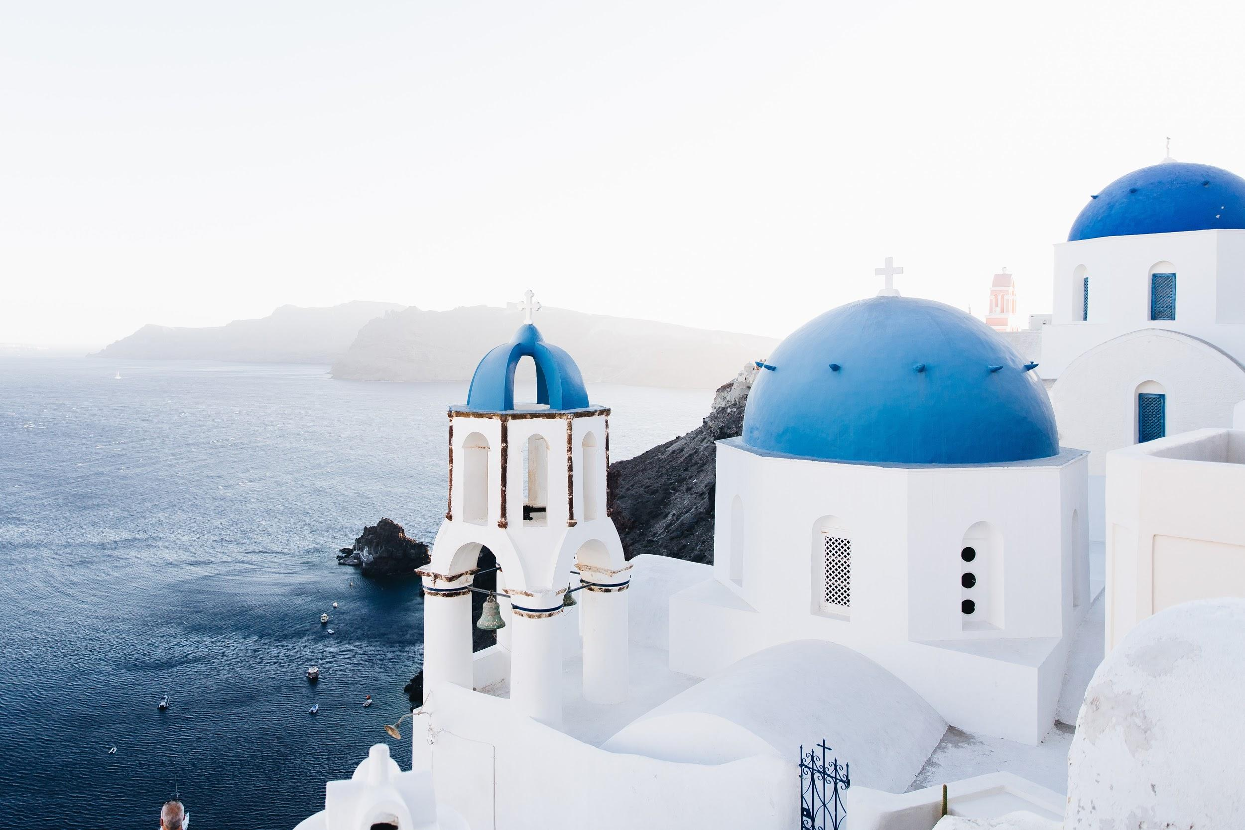

The island of Santorini is one of the destinations included in the 10-day Grand Adventures cruise of the Greek Islands and Italy



Hero image: Charles Bridge in Prague is a must-see for visitors, part of the 10-night Blue Danube Guided Journey

Credit: Shutterstock.com



A view over the Hungarian Parliament Building, one of the sights Club Members will see during the 10-night Blue Danube Guided Journey

Credit: Shutterstock.com

**[headline] Holiday Ideas for 2020**

**[standfirst]** Start checking off your 2020 travel bucket list with RCI’s Select Exchange program

Experience RCI’s carefully curated selection of luxurious resorts and enjoy exclusive travel experiences when you book your next vacation. Through the [RCI Select Exchange program](https://club.hiltongrandvacations.com/en/club-membership/resort-vacation-exchange/select-exchange-rci), Hilton Grand Vacations’ Club Members enjoy exclusive advance access to RCI resorts. And if you're a Member with Elite Status, you can book a reservation 12 months to 3 months before your desired check-in date.

For full program details, visit the [RCI Select Exchange page on the Club website](https://club.hiltongrandvacations.com/en/club-membership/resort-vacation-exchange/select-exchange-rci). While you do, here’s a taster of some of the places you can experience through the program.

**WorldMark Wine Country Sonoma**

Settle down with friends, family or both in California’s wine country when you stay at the picture-perfect WorldMark Wine Country Sonoma. Visit some of the most famous wineries in the country, play a few rounds on the resort’s Windsor Golf Course, or enjoy a swim in the outdoor pool.

**Carpediem Roma Golf Club**

Just 12 miles from Rome, make the elegant Carpediem Roma Golf Club your home base for exploring the Italian capital. Visit the Spanish Steps, the Vatican and the Colosseum, or simply stay at the resort for a game of golf before retreating to your private balcony with a glass of local wine.

**Bluegreen Club La Pension**

Located in the heart of New Orleans, just a few steps from Canal Street, Bluegreen Club La Pension is a boutique resort offering an eclectic style and close proximity to all of the city’s main attractions. Don’t miss a chance to experience all of the fun and festivities that New Orleans has to offer.

For a full list of more than 4,300 resorts in 110 countries, visit the [RCI Select Exchange page](https://club.hiltongrandvacations.com/en/club-membership/resort-vacation-exchange/select-exchange-rci) on the Club website and select **Access Your RCI Account**.

**Login Steps**

To start a vacation search with RCI, follow these steps:

* Log in to [club.hiltongrandvacations.com](https://club.hiltongrandvacations.com/)
* Go to the “Club Membership” section
* Select “RCI and Resort Exchange”
* Click on “Learn More” under “RCI Exchange Reservations”
* Click on “Access Your RCI Account” to link to your RCI subscribing member account

Starting a search or booking?  Call 1-800-932-4482 for personalized help from an RCI Vacation Counselor.

*These vacations are limited and subject to availability and your accessible Points balance.

CST: 2046555-50. Fla. Seller of Travel Reg. No. ST-26552. Nevada Seller of Travel Reg. No. 2002-0793. Washington Seller of Travel Reg. No. 602357907. Registration as a seller of travel does not constitute approval by the State of California.

RCI and related marks are registered trademarks and/or service marks in the United States and internationally. All rights reserved.

© 2020 RCI, LLC. All rights reserved.

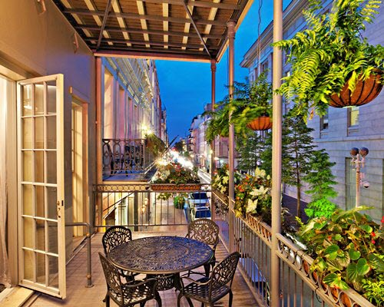

The balcony at boutique New Orleans resort, Bluegreen Club La Pension

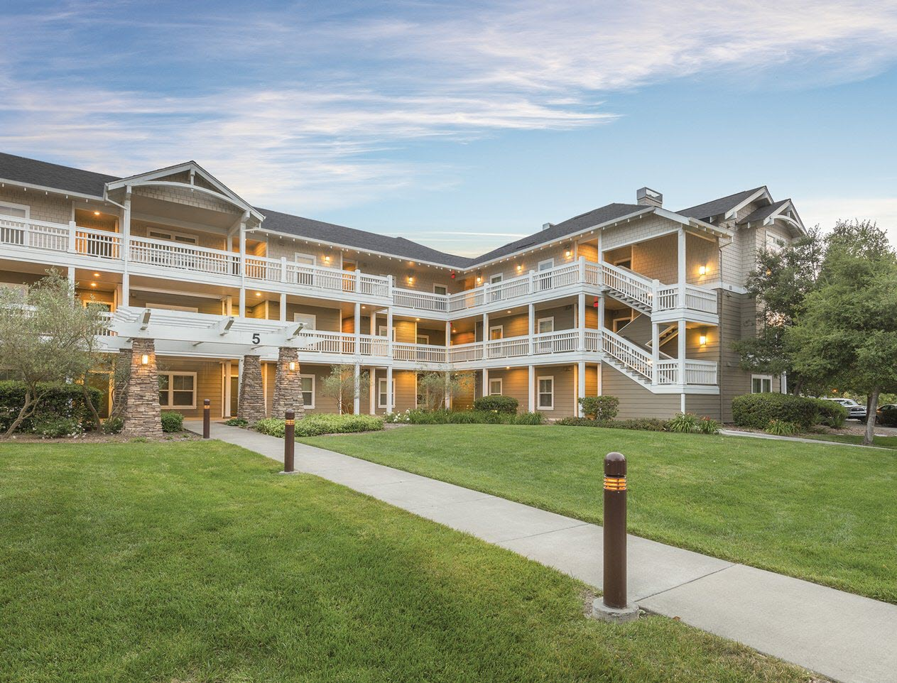

WorldMark Wine Country Sonoma in California’s wine country

**DON’T MISS OUT**

**Club Member Exclusive**: Get a $100 gift card when you book a stay from January 9-23 at Ocean 22 by Hilton Grand Vacations Club in South Carolina and at Kings' Land by Hilton Grand Vacations Club in Hawaii. Visit the [Club Member Exclusives page](https://club.hiltongrandvacations.com/en/club-membership/club-member-exclusives/limited-time-exclusives/resort-specials) for full details, including available stay nights.

**Make a Point:** Make sure you’re not missing any of HGV’s exciting offers and program communications by keeping your contact information updated on the Club Member [website](https://club.hiltongrandvacations.com/en/account#/index). To update your contact information, select **Edit Profile** from your **Member Dashboard** and scroll down until you see the **Primary Account** section.

**Make a Green Resolution:** We know how important sustainability is to our Members and guests. To help reduce our carbon footprint, why not opt-in to receive HOA and loan communications from us via email this year? Log in to the Club website and visit the [Manage Communications page](https://club.hiltongrandvacations.com/en/account#/manage-communications) to get started.

**Program Changes**: The 2020 Club Rules are now available on the Club website! To download the document, follow [this link](https://club.hiltongrandvacations.com/en/club-membership).

[Send us](mailto:input@hgvc.com) your vacation memories!